PHASE 7

TESTING & VALIDATION
Objective:
To test the AI BlogNest application and verify that all implemented features work correctly without errors.
Testing Activities:
- Tested user registration functionality.
- Tested user login functionality.
- Tested JWT-based authentication.
- Tested user profile API.
- Tested blog creation functionality.
- Tested viewing all blogs.
- Tested viewing individual blogs.
- Tested blog update functionality.
- Tested blog deletion functionality.
- Tested AI blog generation.
- Tested AI blog summarization.
- Tested frontend forms and user inputs.
- Tested validation and error messages.
Testing Tools:
- Postman
- Thunder Client
- Web Browser
- MongoDB Compass
Validation:
- Checked whether required fields are validated.
- Checked authentication token handling.
- Verified that valid users can access protected APIs.
- Verified that unauthorized requests are rejected.
- Checked whether blog data is correctly stored in MongoDB.
- Verified that AI-generated content is displayed correctly on the frontend.
Expected Output:
All implemented modules should work correctly, valid data should be processed successfully, and invalid requests should return appropriate error messages.
Phase Status:
Completed.

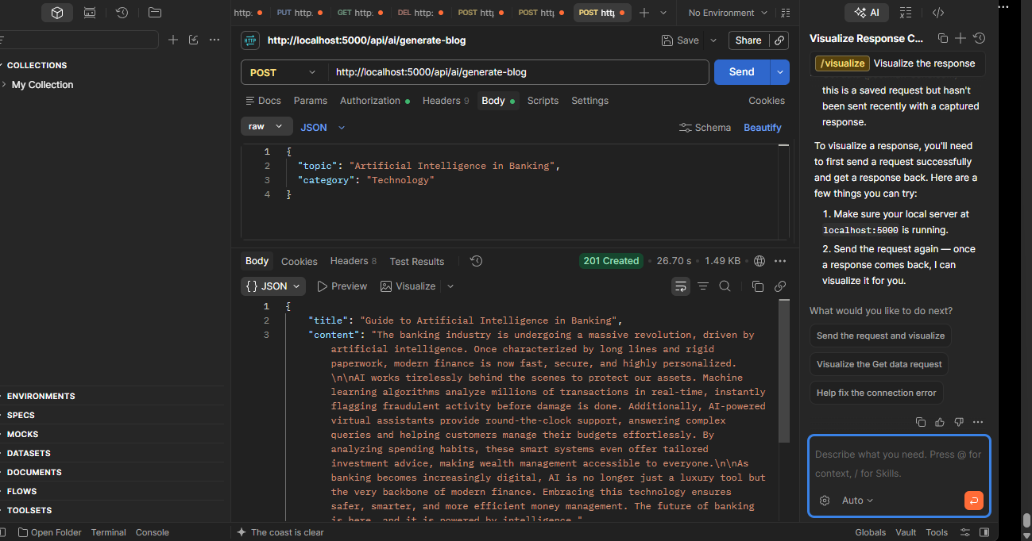
Figure 7.1: AI Blog Generation API Testing and Validation

